Epsom & Ewell F.C.
5
v
Abbey Rangers
Tuesday, 6th September 2016 – 7.45 p.m.
Good evening and just two weeks after they last visited High Road, we meet Abbey Rangers once again, who this time visit us for a League Cup tie. We welcome their players, supporters and officials once again and of course our own followers.

Since defeating our opponents 7-1 we visited Colliers Wood United for a Friday night match that we won’t forget in a hurry, losing 5-0 but bounced back really well to defeat Horley Town 3-0 at High Road just three days later. Daryl Cooper-Smith scored another two goals in that match to bring his tally to eleven in our first eight matches, which is a feat that hasn’t been achieved since a young Tommy Tuite did it back in 1974/75 and hasn’t actually been exceeded since 1952! A quick mention should also go to Matt Farrell who has five goals from midfield already and must be revising his scoring targets for the season.

Hopefully there are many more goals to come, but it must be remembered that this is a team effort and a lot depends on the service. Going into tonight’s match we mustn’t get carried away by looking at our last result and thinking that we just have to turn up, as Abbey ran us very close for a large part of that previous match and have since made changes. They also defeated Badshot Lea 4-0 on Saturday and it is clear that any complacency here will cost us our place in the next round.

Following our win over Horley, we have had eight days spare and it is hard to say whether this is a good thing or not. It will give our injured players some time to heal which is obviously important, although there is a school of thought that says we should want to get more matches played to follow up our win. We’ll soon find out!

September brings us a number of very tough fixtures. Whilst all matches in this League are difficult, there are certain teams that you expect to be up at the business end and Camberley and Knaphill are two of them. They are our next two opponents at High Road, in fact our only two opponents at home until 8th November, unless we get a home Vase draw on 22nd October. We face Camberley this coming Saturday with Knaphill visiting on 24th September. In between those matches is a trip to Badshot Lea who are still at Ash United for this season and we visit surprise package Westfield on Tuesday 27th.

Finally, please note that our match must be settled tonight, so if we are level after 90 minutes, then extra time and possibly penalties could follow if required. The winners visit Hanworth Villa in the Second Round on Tuesday 11th October

Enjoy the game!

Rich

You can follow us on Facebook: www.facebook.com/epsomandewellfc Twitter: @EEFCOfficial and
Instagram at: www.instagram.com/epsomandewellfc We also have a Youtube channel now!

Cover photos by Gemma Jarman

- Matt Farrell striking the ball from twenty yards for our third goal v Horley

- Daryl Cooper-Smith scoring our second goal in the same match

Cherry Red Records Combined Counties League
Premier Division Table 2016/17
including Saturday 3rd September | P | W | D | L | F | A | Pts | GD | H | A
Hartley Wintney | 7 | 5 | 1 | 1 | 19 | 8 | 16 | +11 | 18/3 | 10/12
Westfield | 5 | 5 | 0 | 0 | 14 | 2 | 15 | +12 | 18/2 | 27/9
Windsor | 7 | 4 | 2 | 1 | 14 | 10 | 14 | +4 | 15/11 | 1-2
Bedfont Sports | 6 | 4 | 1 | 1 | 16 | 11 | 13 | +5 | 19/11 | 7/2
Knaphill | 6 | 4 | 0 | 2 | 13 | 10 | 12 | +3 | 24/9 | 8/4
Walton & Hersham | 5 | 3 | 2 | 0 | 7 | 2 | 11 | +5 | 4/3 | 1/10
Hanworth Villa | 7 | 3 | 2 | 2 | 10 | 8 | 11 | +2 | 13/12 | 14/1
Epsom & Ewell | 6 | 3 | 0 | 3 | 21 | 15 | 9 | +6 | X | X
CB Hounslow United | 6 | 3 | 0 | 3 | 10 | 9 | 9 | +1 | 1-5 | 12/11
Chertsey Town | 4 | 3 | 0 | 1 | 5 | 4 | 9 | +1 | 17/12 | 11/2
Spelthorne Sports | 5 | 2 | 2 | 1 | 6 | 4 | 8 | +2 | 7/1 | 25/2
Horley Town | 5 | 2 | 2 | 1 | 8 | 8 | 8 | 0 | 3-0 | 17/4
Camberley Town | 5 | 2 | 0 | 3 | 13 | 9 | 6 | +4 | 10/9 | 1/4
Guildford City | 4 | 2 | 0 | 2 | 8 | 7 | 6 | +1 | 17/1 | 5/11
AFC Hayes | 6 | 2 | 0 | 4 | 8 | 9 | 6 | -1 | 26/11 | 28/1
Abbey Rangers | 6 | 2 | 0 | 4 | 10 | 15 | 6 | -5 | 7-1 | 3/12
Colliers Wood United | 5 | 1 | 2 | 2 | 11 | 9 | 5 | +2 | 14/4 | 0-5
Raynes Park Vale | 7 | 1 | 2 | 4 | 9 | 14 | 5 | -5 | 27/12 | 25/10
North Greenford United | 5 | 1 | 1 | 3 | 6 | 8 | 4 | -2 | 22/4 | 15/10
Sutton Common Rovers | 4 | 1 | 1 | 2 | 5 | 12 | 4 | -7 | 8/11 | 2/1
Farnham Town | 7 | 1 | 1 | 5 | 9 | 17 | 4 | -8 | 25/3 | 8/10
Badshot Lea | 8 | 1 | 1 | 6 | 6 | 21 | 4 | -15 | 4/2 | 17/9
Bedfont & Feltham | 6 | 1 | 0 | 5 | 7 | 23 | 3 | -16 | 21/1 | 9-2

Lucky Day? - 6th September
Played 13 - W 6 D 2 L 5 - F 28 A 31 - PPG 1.54 - Above Average
Our Club record against Abbey Rangers
Played 1 - W 1 D 0 L 0 - F 7 A 1 - PPG 3.00 - Perfect
Largest wins and losses against Abbey Rangers
23rd August 2016 - Won 7-1 - Combined Counties League (H)
Their Last Visit
Tuesday 23rd August 2016 - Won 7-1 - Combined Counties League

First Eleven Appearances 2016/17 - (max 8)
Name | Debut | 2016/17 |  |  |  | Career Totals
 |  | App | Sub | Total | Goals | App | Sub | Total | Goals
CLARK-GLEAVE Charlie | 23/08/2016 | 1 | 0 | 1 | 0 | 1 | 0 | 1 | 0
COOPER-SMITH Daryl | 03/01/2015 | 8 | 0 | 8 | 11 | 38 | 8 | 46 | 31
DEAN Dan | 02/08/2014 | 3 | 1 | 4 | 0 | 71 | 5 | 76 | 2
EACOTT Michael | 02/08/2014 | 5 | 0 | 5 | 0 | 90 | 1 | 91 | 0
FARRELL Matt | 02/08/2014 | 8 | 0 | 8 | 5 | 94 | 4 | 98 | 23
FERDINANDO Matt | 20/09/2014 | 3 | 1 | 4 | 1 | 56 | 7 | 63 | 15
GALLAGHER Jordan | 07/08/2016 | 2 | 4 | 6 | 2 | 2 | 4 | 6 | 2
GRIFFIN Reisse | 08/08/2015 | 6 | 1 | 7 | 0 | 34 | 7 | 41 | 2
HASTINGS Craig | 08/08/2015 | 6 | 2 | 8 | 0 | 43 | 6 | 49 | 0
HEAGNEY Adam | 16/08/2015 | 3 | 2 | 5 | 0 | 3 | 2 | 5 | 0
HENDRY Rob | 08/08/2015 | 5 | 3 | 8 | 1 | 35 | 14 | 49 | 13
MCKAY Alex | 20/12/2008 | 1 | 2 | 3 | 0 | 109 | 32 | 141 | 8
NEALE Tom | 13/10/2015 | 3 | 2 | 5 | 4 | 19 | 21 | 40 | 14
NORTH Rhys | 16/08/2015 | 2 | 2 | 4 | 0 | 19 | 9 | 28 | 1
PANAYIOTOU Savvas | 03/01/2015 | 3 | 2 | 5 | 0 | 35 | 10 | 45 | 7
PRICE Matt | 23/08/2016 | 2 | 0 | 2 | 1 | 2 | 0 | 2 | 1
ROBINSON Sam | 22/10/2011 | 6 | 1 | 7 | 1 | 60 | 6 | 66 | 14
TANTON Matt | 02/08/2014 | 6 | 1 | 7 | 0 | 63 | 5 | 68 | 2
TAYLOR James | 26/08/2013 | 8 | 0 | 8 | 0 | 94 | 12 | 106 | 6
THOMPSON Elliott | 09/02/2016 | 3 | 0 | 3 | 1 | 7 | 9 | 16 | 1
TURPIE Alistair | 31/03/2016 | 3 | 0 | 3 | 0 | 5 | 0 | 5 | 0
WATRET Jack | 02/08/2016 | 1 | 0 | 1 | 0 | 1 | 0 | 1 | 0

Latest Results and Fixtures
Combined Counties League – Friday 26th August
Colliers Wood United | 5-0 | Epsom & Ewell
Combined Counties League – Saturday 27th August
Abbey Rangers | 0-2 | Bedfont Sports
Badshot Lea | 0-3 | Westfield
Bedfont & Feltham | 0-2 | Raynes Park Vale
Camberley Town | 1-2 | Chertsey Town
Farnham Town | 2-2 | Spelthorne Sports
Horley Town | 2-1 | Hanworth Villa
Knaphill | 2-1 | AFC Hayes
North Greenford United | 1-1 | Windsor
Sutton Common Rovers | 2-8 | Hartley Wintney
Walton & Hersham | 1-0 | Guildford City
Combined Counties League – Monday 29th August
AFC Hayes | 3-0 | North Greenford United
Bedfont Sports | 4-1 | Bedfont & Feltham
Chertsey Town | 1-0 | Abbey Rangers
Epsom & Ewell | 3-0 | Horley Town
Guildford City | 2-0 | Badshot Lea
Hanworth Villa | 0-1 | CB Hounslow United
Hartley Wintney | 2-1 | Camberley Town
Spelthorne Sports | 2-0 | Knaphill
Westfield | 3-1 | Farnham Town
Windsor | 0-0 | Walton & Hersham
Combined Counties League – Tuesday 30th August
Raynes Park Vale | 2-2 | Colliers Wood United
Emirates F.A. Cup First Qualifying Round – Saturday 3rd September
Camberley Town | 0-2 | Hastings United
CB Hounslow United | 1-3 | Met Police
Thamesmead Town | 1-0 | Chertsey Town
Colliers Wood United | 2-0 | Eastbourne Town
Bognor Regis Town | 5-1 | Guildford City
Folkestone Invicta | 3-1 | North Greenford United
Combined Counties League – Saturday 3rd September
Abbey Rangers | 4-0 | Badshot Lea
Bedfont Sports | 1-4 | Walton & Hersham
Hanworth Villa | 0-0 | Hartley Wintney
Knaphill | 2-1 | Farnham Town
Sutton Common Rovers | 2-1 | Spelthorne Sports
Latest Results and Fixtures
Combined Counties League – Saturday 3rd September
Westfield | 2-1 | AFC Hayes
Windsor | 2-0 | Raynes Park Vale
Combined Counties League Cup First Round – Tuesday 6th September
CB Hounslow United | V | Farnham Town
Cobham | V | Bagshot
Epsom & Ewell | V | Abbey Rangers
Knaphill | V | Camberley Town
Westfield | V | North Greenford United
Combined Counties League – Tuesday 6th September
Badshot Lea | V | Colliers Wood United
Hartley Wintney | V | AFC Hayes
Spelthorne Sports | V | Windsor
Combined Counties League Cup First Round – Wednesday 7th September
Redhill | V | Bedfont & Feltham
Match to be played at Bedfont & Feltham FC
Combined Counties League – Wednesday 7th September
Guildford City | V | Chertsey Town
F.A. Vase First Qualifying Round – Friday 9th September
Badshot Lea | V | Farnham Town
Combined Counties League – Saturday 10th September
Epsom & Ewell | V | Camberley Town
Hartley Wintney | V | Knaphill
Walton & Hersham | V | Sutton Common Rovers
F.A. Vase First Qualifying Round – Saturday 10th September
AFC Hayes | V | Crawley Green
Arundel | V | Westfield
Bedfont & Feltham | V | Sandhurst Town
Bedford | V | CB Hounslow United
Bridon Ropes | V | Colliers Wood United
Chertsey Town | V | Lydney Town
Daventry Town | V | Windsor
Guildford City | V | Eastbourne United
Hanworth Villa | V | Bedfont Sports
Horley Town | V | Hassocks
Raynes Park Vale | V | Haywards Heath Town
Shrivenham | V | Abbey Rangers
Spelthorne Sports | V | Tring Athletic
Stotfold | V | North Greenford United

From behind the goal
Colliers Wood United 5-0 Epsom & Ewell
Combined Counties League - Premier Division - Friday 26th August 2016

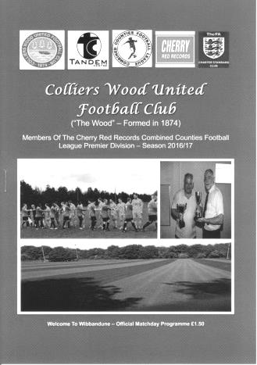
Friday night disaster at Wibbandune

Our club's first ever visit to Wibbandune came on 21st February 2007. It was our first meeting with Colliers Wood United and as we retired defeated by three clear goals, some supporters had the added annoyance in finding that a number of their cars had been broken into during the game. It is hard to imagine a more disappointing evening than that, but our latest result and performance there completely eclipses that evening in every way.

Because make no mistake, this was a shocker. Incredibly, this sort of turnaround in results, following our 7-1 win just three days previously, has happened before, in 1949 and in 1964, but on both occasions we had a poor team that finished way down the table. Surely a team that has looked brilliant at times already this season will not face a similar fate? In looking a long way back to find a comparable performance to this I had to go back to a 6-1 home defeat against Egham Town at Merland Rise. Imagine my surprise when I realised that the Egham match actually took place exactly ten years to the day before this one!

What is even harder to fathom is that there was only one change from the team that completed the 7-1 win over Abbey Rangers with Daryl Cooper-Smith starting and Rob Hendry who had replaced him on Tuesday, going back on the bench. For our hosts, the evergreen former Epsom legend Dale Marvell was back in the centre of defence with former Salt Sean White making an entrance later in the match.

There is little point in an inquest and to be fair, that's not my job. I shall concentrate on the facts, and the evening got off to the worst possible start with just one minute and 46 seconds on the clock when a harmless enough looking ball came over from the left and as the ball fell Darren Caesar belted it around twenty-five yards and couldn't have hit it better, as the ball sailed over Alistair Turpie and just under the bar. Maybe on nine out of ten occasions it may have ended up in the trees behind the goal but you don't win the raffle if you don't buy a ticket, so credit must be given for the strike, which arguably ought to have been closed down.

Cooper-Smith was rightly flagged offside as he saw his equaliser chalked off in the sixth minute but the opening twenty minutes were fairly promising as we controlled the ball for a large part of the next half an hour. Surely the equaliser would come as a number of free kicks were placed into dangerous areas with Matt Price having earned most of them as the home side appeared to want to take him out of the game. He was clattered from behind by Charlie Emery and required treatment and when Marvell went through him a few minutes later the referee produced the yellow card. Despite having the set pieces, nothing came from them and we created little with Jordan Gallagher and Agi Panayiotou on the flanks having absolutely no impact on the game. Gallagher was floored in the penalty area on one occasion but I felt the defender had got the ball, although others around me felt that wasn't the case.

Both Reisse Griffin and then Craig Hastings picked up yellow cards for impeding players as the home side threatened to break away on the counter attack and as our game started to deteriorate

we nearly conceded a stupid goal when we were too casual at the back and were lucky to be able to clear the danger. However, we didn't heed the warning and a right wing cross was tucked away at the near post by Mario Embalo in the fourth minute of injury time, ironically earned by Price's treatment time.

The riot act was read out at half time as anyone fairly near to the dressing rooms could hear, but unlike on that bizarre evening at Bedfont & Feltham there was no response and it was the home team who started to play a bit more football. They hit the post from a corner but on the counter attack Price and Cooper-Smith did well to rob the defender and the latter reached the ball first to score, but was offside when Price wouldn't have been. Then when Marvell tried to chest a right wing cross back to his keeper he misjudged it and the ball missed his own post by inches.

It was becoming apparent that it wasn't going to be our night and this was confirmed moments later on a counter attack from that corner when Embalo's low shot wasn't held by Turpie and Eli Ogunseye was there to knock in the rebound in the 56th minute. A couple of substitutions followed with our two wingers withdrawn and one of the introductions, Hendry nearly got through immediately but his left wing cross was just cleared by a defender for a corner ahead of Price. From the corner Hastings got his head to the ball but the attempt was tipped over and the opportunity was gone.

Our day of frustration got worse in the 70th minute when a right wing cross from Sanchez Benali couldn't have been placed better if he had put the ball there himself and it fell straight onto the foot of Ogunseye who gave Turpie no chance from close range. It seemed that everything was dropping for the opposition while things just weren't happening and frustrations with a referee who seemed either oblivious or completely disinterested in an obscene amount of wasting time by Andrew Osei in the Wood goal, came to a head when he allowed him to disappear into the undergrowth behind the goal in an attempt to retrieve a ball without stopping the clock.

Yet the day was to get worse still when Sam Robinson, having been booked for a poor challenge in the 73rd minute, couldn't resist the urge to get involved with an opposition player and when both received a yellow card our man had to go, marking his club record equalling fifth dismissal in club colours in just his 65th appearance. Why such a nice guy off the field cannot control himself on it remains a mystery.

A fifth goal duly followed in the 90th minute when a low drive from Dan Hughes beat Turpie at his near post, although in injury time he made two good saves to restrict the hosts from making further dents in what had been up until this point, a decent goal difference. Unfortunately the final action of the match came when Price stretched for a ball and although it was hard to see exactly what happened, he was on the ground in obvious discomfort for the next few minutes with what looked like a nasty injury. Despite my understanding that time is supposedly stopped for an injury, or else what exactly is "injury time" otherwise, the referee then decided to end the game without restarting the match.

On another night the extremely odd officiating might have been analysed in more detail, but as we let ourselves down so badly with misplaced passes and poor football it would be wrong to look anywhere else for the reason we were so conclusively taken apart. Although Colliers Wood played well on the night, this defeat was most definitely down to us.

Epsom and Ewell: Alistair Turpie, Adam Heagney, Reisse Griffin, James Taylor, Craig Hastings, Sam Robinson, Jordan Gallagher, Matt Farrell (c), Matt Price, Daryl Cooper-Smith,
Savvas 'Agi' Panayiotou

Subs: Matt Tanton for Panayiotou (58), Rob Hendry for Gallagher (58),
Dan Dean for Hastings (75)

From behind the goal
Epsom & Ewell 3-0 Horley Town
Combined Counties League - Premier Division - Monday 29th August 2016

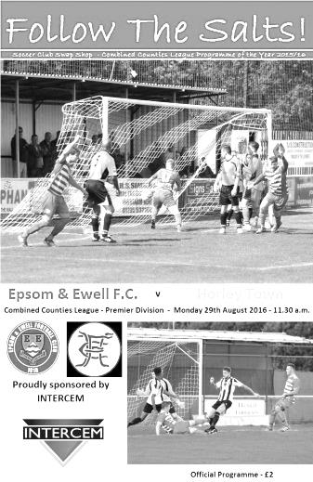
Salts bounce back to claim local bragging rights

Following Friday night's result at Colliers Wood, you would be excused for thinking that we would do well to recover so quickly, especially against a team that had beaten the leaders Hanworth Villa two days previously and also contained in their ranks our former scoring legend Kyle Hough. However, our boys scrapped for everything, got off to a good start and by the end were comfortable winners. It was also the first time in five meetings between the teams that all 22 players finished the match!

There were some changes to the line-up with Michael Eacott coming in for Alistair Turpie between the posts, while at the back Dan Dean and Matt Tanton returned to the starting eleven. This enabled Reisse Griffin to return to the right wing and Rob Hendry started on the left. Equally importantly Savvas 'Agi' Panayiotou moved to a defensive midfield role which enabled Sam Robinson to play further forward. Already the team looked a lot more balanced to the untrained eye (mine!).

And after an even first few minutes we opened up our account in the 9th when Matt Farrell produced a deep right wing delivery for Daryl Cooper-Smith to continue his rich run of scoring form to head his tenth goal in just eight matches from close range.

The visitors hit straight back with a long range effort that looked on target but deflected off a defender for a corner and passed the ball around confidently as befitted a team that were previously unbeaten in league action. We were restricted to a couple of half chances but to be fair our pressing was keeping the visitors at distance also, with no way of supplying Hough with any sort of service. As the half progressed Panayiotou made a great run through the middle but a saving challenge rebounded the ball off him and through to the grateful Luke Burton in the Horley goal.

However, we nearly had a disaster of our own making in the 42nd minute when Eacott called for the ball but James Taylor got there first and headed the ball past his keeper and towards the goal, picking up a clattering from his teammate in the process. Adam Heagney was able to retrieve the ball and put it out of play before any of the opposition could take advantage and Taylor recovered after treatment. Finally, with the last action of the half Hough received the ball and ran at Tanton but our defender forced him across goal and although he still got a shot in, he pulled it well wide of Eacott's far post.

If the first half had been a little nervy, the second half was a lot more comfortable and nearly started with an Epsom goal in the opening thirty seconds as Cooper-Smith got through but his early shot was well saved by Burton getting down low to his right and Horley's Captain

Adam Pullin made a great saving challenge to deny Robinson as he was in the process of crossing to a wide open Cooper-Smith moments later.

Tanton received a stern talking to from the referee for a late challenge, but to be fair the official had been equally lenient in the first half after a Liam Giles foul on Robinson and when Corey Mullings threw the ball at Tanton, so we did at least have consistency. Hendry fired over from Griffin's cross as we began to take a measure of control in the second half and this was underlined in the 57th minute when Taylor put the ball through to Cooper-Smith who ran in on goal and calmly finished low past Burton. Incredibly at this rate our striker could end up with 66 goals this season. Let's hope so!

The first card of the match was shown to Jack Poplett for a clumsy foul on Panayiotou before Hough followed him into the book for something he said to the referee. Horley were trying to make something happen and after a good bit of pressure headed over the bar from close range. However, we were back on the attack again soon after and Cooper-Smith received the ball from a quick throw and lobbed it across goal but it just wouldn't come down in time and Griffin was unable to keep the header down. In the 73rd minute Robinson turned provider again and found Cooper-Smith in acres of space just inside the area but his control let him down really badly and his third hat trick of the season would have to wait for another day as the danger was cleared.

Jordan Gallagher replaced Hendry after 74 minutes and Rhys North replaced Heagney who came off worst in a solid tackle before the ball was fizzed across our area and out for a goal kick. In the 85th minute we made the points safe after good work by Cooper-Smith and Gallagher, and just when it looked as though we weren't going to be able to get a shot in the ball was fed to Farrell who drilled the ball into the corner of the net past the helpless Burton from 20 yards in the 85th minute.

So now it was all about whether we could keep a clean sheet and we had a close scare after substitute Richard Wetton just cleared the bar in an attempt to chip the advancing Eacott after our defenders were absent for a moment. Craig Hastings came on for Cooper-Smith with Dean moving up into midfield and two further chances occurred as Panayiotou's shot was deflected wide and from the corner Hastings met the ball at the far post, but his header was well blocked by Burton. Near the end we had a little spat in the middle of the field that led to Dean receiving a card to go with one that Tanton had picked up a few minutes earlier and then finally in the ninth minute of injury time the referee blew the final whistle.

Obviously it goes without saying that this was a real show of character from our boys. In America this would be what they call "a statement win". Not only did it remind everyone that we are still capable of competing with any other team in this League, but it also proved both to supporters and our players what we already knew; that we are quite a good team. We can now write off the previous game as a bad day at the office and move on. It is always good to beat our local rivals, especially with Hough in their team who managed just one shot on target in the entire match. Now we just need to work on our consistency.

Epsom and Ewell: Michael Eacott, Adam Heagney, James Taylor, Dan Dean (c),
Savvas 'Agi' Panayiotou, Rob Hendry, Matt Farrell (c), Daryl Cooper-Smith,
Sam Robinson, Reisse Griffin

Subs: Jordan Gallagher for Hendry (74), Rhys North for Heagney (80),
Craig Hastings for Cooper-Smith (88)

EL Records Premier Challenge Cup
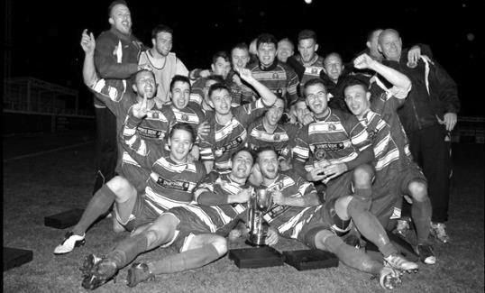
First Round
Redhill | 6/9 | Bedfont & Feltham
Spelthorne Sports | 13/9 | Sutton Common Rovers
Knaphill | 9/9 | Camberley Town
Worcester Park | 24/9 | Dorking
Epsom & Ewell | 6/9 | Abbey Rangers
Westfield | 6/9 | North Greenford United
Cobham | 6/9 | Bagshot
CB Hounslow United | 6/9 | Farnham Town
South Park Reserves | 14/9 | Balham
Second Round
Hanworth Villa | 11/10 | 5
AFC Hayes | 4/10 | 9
Epsom Athletic | 28/9 | Windsor
2 | V | Bedfont Sports
Raynes Park Vale | 4/10 | Colliers Wood United
Frimley Green | 4/10 | Banstead Athletic
6 | 4/10 | 1
Staines Lammas | 15/10 | 8
4 | V | Cove
Badshot Lea | 4/10 | Guildford City
Chertsey Town | 4/10 | 3
7 | V | Chessington & Hook United
Hartley Wintney | 4/10 | AC London
Horley Town | 4/10 | Sheerwater
Walton & Hersham | 4/10 | Eversley & California
Ash United | 11/10 | Farleigh Rovers

Surrey Senior Cup
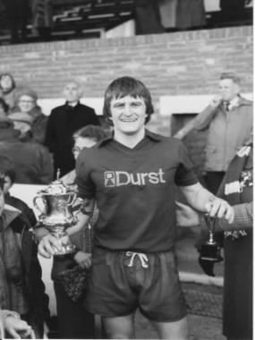
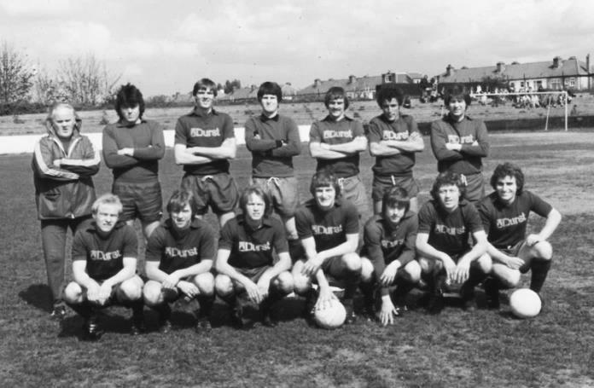
First Round
Abbey Rangers | V | AFC Croydon Athletic
Whyteleafe | V | Westfield
Second Round
Kingstonian | V | Met Police
Ashford Town (Mx) | V | Knaphill
Woking | V | Walton Casuals
2 | V | Colliers Wood United
Guildford City | V | Horley Town
Egham Town | V | Corinthian Casuals
Godalming Town | V | Merstham
Molesey | V | Leatherhead
Raynes Park Vale | V | Sutton United
Sutton Common Rovers | V | Camberley Town
Dorking Wanderers | V | South Park
Badshot Lea | V | Farnham Town
Walton & Hersham | V | Croydon
Carshalton Athletic | V | Tooting & Mitcham United
Chertsey Town | V | 1
Epsom & Ewell | V | Chipstead

Centre page for results

Centre page for results

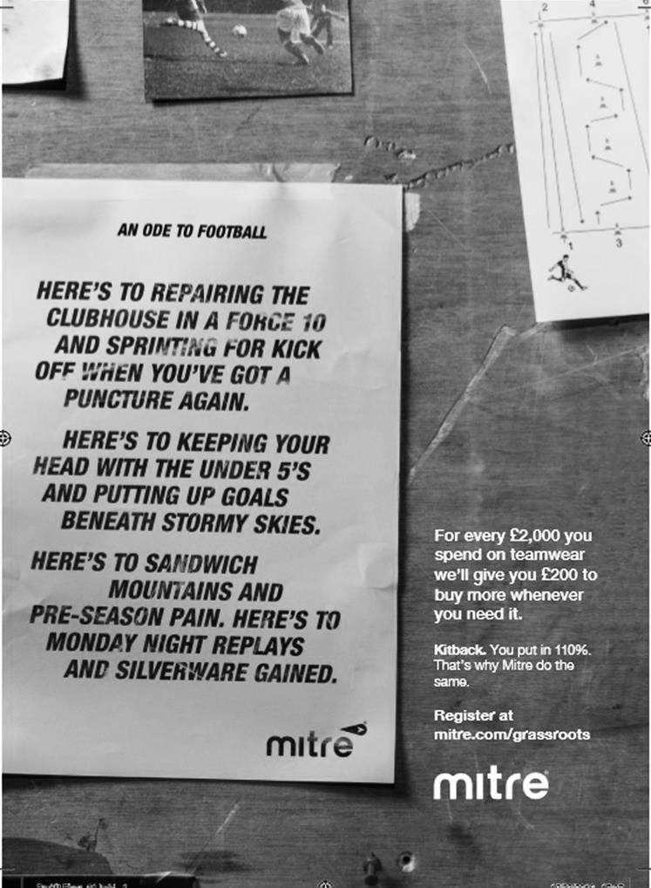

Abbey Rangers – History
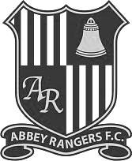
Abbey Rangers Football Club was formed in 1976 to initially promote and provide football for young boys between the ages of 6 through to 16 and taking its name from the historic Chertsey Abbey.

In the initial years Abbey Rangers had a rather nomadic existence having to use various home grounds within Chertsey and Addlestone but as the club grew in size it became clear that the club needed to plant its roots and were able to do so when we established a home on the old Meads school playing fields now known as Addlestone Moor. That ground now accommodates all formats of football from 5 v 5 up to adults.

After years of effort, the club opened up its new clubhouse in 2008, a superb and very welcoming facility partly funded by the Football Foundation. The facility was officially opened by Sir Trevor Brooking on 3rd June 2008.

The club has attained the FA Charter Community Status, and now have a healthy and growing girls and ladies section. The club also prides itself on being one of the leading lights in Surrey at providing disability football.

On the pitch, this team has made good progress over the years. After joining what is now known as the Guildford & Woking Alliance the club made big strides through the divisions and in 2008 we gained promotion to the Surrey County Intermediate League (Western) Division One winning the division at the first attempt and ensuring promotion to the Premier Division. We spent three seasons in the SCILW Premier Division finishing runners up in 2010-11 and 2011-12. After finishing runners up the 2nd time we took our place in the Surrey Elite League where we remained for three seasons finishing 5th, 3rd and 4th and winning the League cup in 2013-14.

The long term plan though for the club was always to reach the Combined Counties League and after extensive work and investment on the ground we were proud to finally be able to achieve that goal and take our place in 2015.

Our first season at this level has seen us make decent strides in the league but the clubs maiden foray in the FA Vase saw us cover some miles in reaching the 2nd round proper of that competition, the highlight being a 2-1 win at one of the pre-tournament favourites AFC Portchester. We finally succumbed to Wessex League Premier outfit Newport IOW in extra time.

Our league form improved and an unbeaten run that began at Christmas saw us finish in 3rd place and in doing so gaining promotion to the Combined Counties Premier Division at the first attempt.

This season saw another first for the club as we took our bow in the FA Cup, although it was all over very briefly as we lost 3-0 at Hellenic League Thame United.

Combined Counties League Premier Division Opponents
All-time Records
inc Saturday 3rd September | P | W | D | L | F | A | PPG | GD | Best  Win | Worst  Loss
Bedfont & Feltham | 1 | 1 | 0 | 0 | 9 | 2 | 3.00 | +7 | 9-2 | X
Abbey Rangers | 1 | 1 | 0 | 0 | 7 | 1 | 3.00 | +6 | 7-1 | X
Spelthorne Sports* | 5 | 4 | 1 | 0 | 15 | 6 | 2.60 | +9 | 6-2 | X
Sutton Common Rovers | 10 | 8 | 1 | 1 | 27 | 12 | 2.50 | +15 | 4-0 | 1-4
Horley Town | 29 | 20 | 5 | 4 | 65 | 30 | 2.24 | +35 | 6-0 | 1-3
Colliers Wood United | 22 | 14 | 2 | 6 | 45 | 33 | 2.00 | +12 | 4-0 | 0-5
Westfield | 18 | 11 | 3 | 4 | 39 | 29 | 2.00 | +10 | 6-1 | 0-4
Bedfont Sports | 9 | 5 | 2 | 2 | 13 | 10 | 1.89 | +3 | 3-0 | 0-4
Farnham Town | 13 | 7 | 2 | 4 | 23 | 22 | 1.77 | +1 | 3-1 | 1-4
Guildford City | 16 | 9 | 1 | 6 | 32 | 22 | 1.75 | +10 | 5-1 | 1-5
Hanworth Villa | 14 | 7 | 3 | 4 | 34 | 24 | 1.71 | +10 | 5-0 | 1-4
Raynes Park Vale | 26 | 13 | 5 | 8 | 57 | 36 | 1.69 | +21 | 6-1 | 0-2
Knaphill | 6 | 3 | 1 | 2 | 11 | 8 | 1.67 | +3 | 4-1 | 1-2
Walton & Hersham | 49 | 24 | 9 | 16 | 100 | 96 | 1.65 | +4 | 6-0 | 0-8
Camberley Town* | 88 | 38 | 21 | 28 | 158 | 123 | 1.54 | +35 | 9-1 | 0-4
Hartley Wintney | 10 | 4 | 3 | 3 | 25 | 17 | 1.50 | +8 | 5-0 | 2-4
Badshot Lea | 17 | 7 | 3 | 7 | 31 | 33 | 1.41 | -2 | 4-1 | 0-4
Windsor | 48 | 18 | 12 | 18 | 88 | 90 | 1.38 | -2 | 4-0 | 0-6
Chertsey Town | 47 | 17 | 5 | 25 | 70 | 86 | 1.19 | -16 | 3-0 | 0-7
AFC Hayes | 8 | 2 | 2 | 4 | 16 | 15 | 1.00 | +1 | 7-0 | 0-3
CB Hounslow United | 2 | 0 | 0 | 2 | 2 | 7 | 0.00 | -5 | X | 1-5
* includes one abandoned match v Camberley and one loss on penalties v Spelthorne

CCL Premier Division Club Directory
ABBEY RANGERS Telephone: 01932-422962 - Ground: Addlestone Moor, Addlestone, Surrey KT15 2QH - Colours: Black & White Stripes/Black/Black

A.F.C. HAYES Telephone: 0208-845-0110 - Ground: Farm Park, Kingshill Avenue, Hayes, Middx. UB4 8DD - Colours: Blue and White Stripes/Blue/Blue

BADSHOT LEA Telephone: 01252-320385 - Ground: Ash United FC, Shawfield Stadium, Youngs Drive, Shawfields Road, Ash, Hampshire. GU12 6RE - Colours: Claret/White/Claret

BEDFONT & FELTHAM Telephone: 0208 890 7264 - Ground: The Orchard, Hatton Road, Bedfont, Middx TW14 9QT - Colours: Yellow & Blue/Blue/Blue

BEDFONT SPORTS Telephone: 0208-831-9067 - Ground: Bedfont Sports Club, Hatton Road, Bedfont, Middx TW14 8JA - Colours: Red & Black Hoops/Black/Red & Black Hoops

CAMBERLEY TOWN Telephone: 01276-65392 - Ground: Krooner Park, Wilton Road, Camberley, Surrey. GU15 2QW - Colours: Red & White Stripes/Blue/Red

CB HOUNSLOW UNITED Telephone: 0208 890 7264 - Ground: The Orchard, Hatton Road, Bedfont, Middx TW14 9QT - Colours: Green/Black/Green

CHERTSEY TOWN Telephone: 01932-561774 - Ground: Alwyns Lane, Chertsey, Surrey. KT16 9DW - Colours: Royal Blue & White Stripes/Royal Blue/Royal Blue

COLLIERS WOOD UNITED Telephone: 0208-942 8062 - Ground: Wibbandune Sports Ground, Robin Hood Way, Wimbledon. SW20 0AA - Colours: Blue & Black Stripes/Black/Black
EPSOM & EWELL Telephone: 01737-553250 - Ground: Chipstead FC, High Road, Chipstead, Surrey. CR5 3SF - Colours: Royal Blue & White Hoops/Royal Blue/Royal Blue

FARNHAM TOWN Telephone: 01252-715305 Ground: Memorial Ground, Babbs Mead, West Street, Farnham, Surrey. GU9 7DY Colours: - Claret & Sky Blue /White/ Claret & Sky Blue

GUILDFORD CITY Telephone: 01483-443322 - Ground: The Spectrum, Parkway, Guildford, Surrey. GU1 1UP - Colours: Red & White Stripes/Black/Black

HANWORTH VILLA Telephone: 0208-831-9391 - Ground: Rectory Meadows, Park Road, off Hounslow Road, Hanworth, Middlesex. TW13 6PN - Colours: Red & White Stripes/Black/Black

HARTLEY WINTNEY Telephone: 01252-843586 - Ground: Memorial Playing Fields, Green Lane, Hartley Wintney, Hants RG27 8DL - Colours: Orange & Black/ Orange /Orange

HORLEY TOWN Telephone: 01293-822000 - Ground: The New Defence, Anderson Way, Court Lodge Road, Horley, Surrey. RH6 8SP - Colours: Claret & Sky Blue/Claret/Claret

KNAPHILL Telephone: 01483-475150 - Ground: Brookwood Country Park, Redding Way, Lower Guildford Road, Knaphill, Surrey. GU21 2AY - Colours: Red/Black/Red

NORTH GREENFORD UNITED Telephone: 0208 422 8923 - Ground: Berkeley Fields, Berkeley Avenue, Greenford, Middx UB6 0NX - Colours: Royal Blue & White/Royal Blue/Royal Blue

SUTTON COMMON ROVERS Telephone: 01932-866386 - Ground: Sutton United FC, Gander Green Lane, Sutton, Surrey SM1 2EY - Colours: Yellow/Black/Black

RAYNES PARK VALE Telephone: 020-8540-8843 - Ground: Prince Georges Playing Field, Grand Drive, Raynes Park, London. SW20 9NB - Colours: Blue/Blue/Red

SPELTHORNE SPORTS Telephone: 01932-961055 - Ground: Spelthorne Sports Club, Staines Road, Ashford Common, Ashford, Middx. TW15 1RY - Colours: Light & Dark Blue/Dark Blue/Light Blue

WALTON & HERSHAM Telephone: 01932 245263 - Ground: Stompond Lane, Walton on Thames, Surrey KT12 1HF - Colours: Red/Red/Red

WESTFIELD Telephone: 01483-771106 - Ground: Woking Park, Kingfield Road, Woking, Surrey. GU22 9BA - Colours: Yellow/Black/Black

WINDSOR Telephone: 01753-860656 - Ground: Stag Meadow, St Leonards Road, Windsor, Berks SL4 3DR - Colours: Red/Red/Red

Milestones and Birthdays
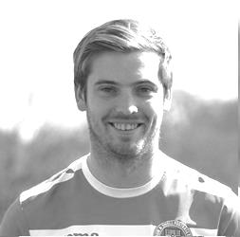
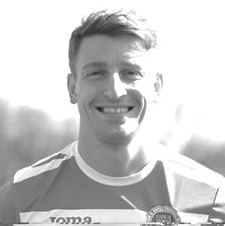
Congratulations to Rob Hendry and Craig Hastings who, assuming they are selected will make their 50th appearances today. Interestingly, they both made their debuts the same day in our 2015/16 season opener at home to Windsor, which we drew 2-2 on 8th August 2015.

Rob opened up his scoring account on his debut and has scored 13 goals for us, in addition to the added bonus of being the only Salts player to ever score for us away from mainland England when he got two goals in our friendly match at Chantilly.

Craig has yet to open his scoring account but I recall marking 50 appearances in recent times for both Dan Dean and Sam Currie and neither of those had scored for the club by that point either, but scored soon after. It is fair to say that he is due a goal, having done everything but score in his time with us. It will come!

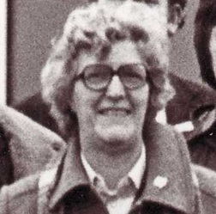
We have a lot of birthdays at the club in September, starting with our Club President Stella Lamont who was 88 on 1st September. Stella has recently been honoured with a long service award by the Surrey F.A. and whilst she has been unable to get to any matches since we left Merland Rise in 2010, she still follows us and looks out for our results.

On 2nd September Sam Robinson celebrated his 27th birthday and this Thursday, 8th September Michael Eacott reaches the landmark age of 21. Our Captain Dan Dean also has his 27th birthday this month, celebrating on 14th, and finally on 30th September James Taylor will be 23. With both Michael and James being as young as they are, who knows how many appearances they in particular could make for us by the time they are finished. Congratulations to all!

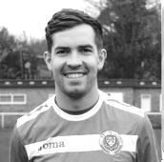
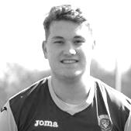
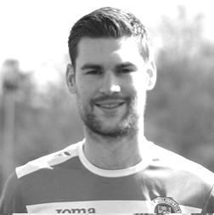
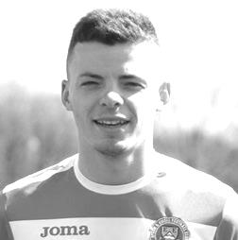

Player Sponsorship
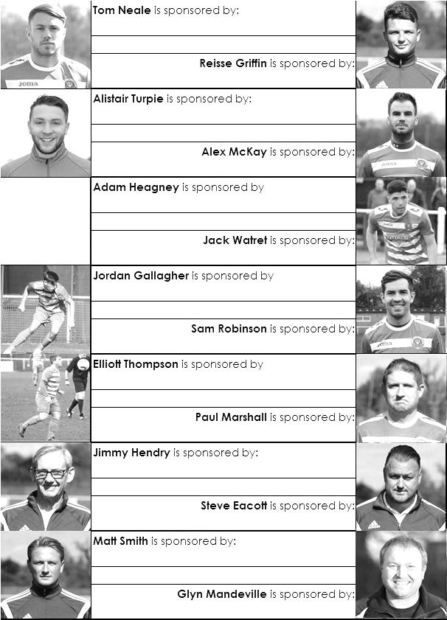

Here is the opening list for the 2016/17 season showing all of our players and Management that are currently available for sponsorship.

Sponsorship costs just £40 and it is easy to do. Just select a player who has not been previously sponsored and let a Committee Member know that you would like to sponsor them. Beware though. Until we have received the money it is possible for someone to jump in front of you, so don’t delay, sponsor today!
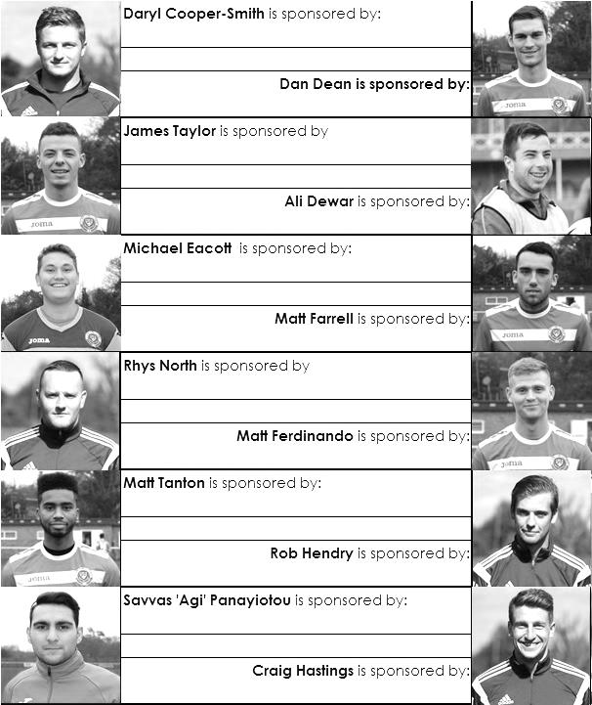

Match and Ball Sponsorships – 2016/17
Opponent | Date | Match Sponsor | Ball Sponsor
Gravesham Borough | 07/08/16 | Club President - Stella Lamont
Gravesham Borough | 07/08/16 | Relocation Committee Member - Mike Lovett
CB Hounslow United | 16/08/16 | EEFC Management Committee
Abbey Rangers | 23/08/16 | Steve & Geoff Dyke
Horley Town (11.30am) | 29/08/16 | In Memory of Chris Henry
Abbey Rangers (LC) | 06/09/16 | Paul Merritt
Camberley Town | 10/09/16
Guildford City | 13/09/16
Knaphill | 24/09/16
Sutton Common Rovers | 08/11/15
Windsor | 15/11/16
Bedfont Sports | 19/11/16
AFC Hayes | 26/11/16
Chipstead (SSC) | 06/12/16
Hanworth Villa | 13/12/16
Chertsey Town | 17/12/16
Raynes Park Vale (11.30am) | 27/12/16
Spelthorne Sports | 07/01/17
Bedfont & Feltham | 21/01/17 | Programme Editor - Richard Lambert
Badshot Lea | 04/02/17
Westfield | 18/02/17
Walton & Hersham | 04/03/17
Hartley Wintney | 18/03/17
Farnham Town | 25/03/17
Colliers Wood United (1.00pm) | 14/04/17 | Good Friday match – make a note!
North Greenford United | 22/04/17
 | tba | F.A. Vase – if drawn at home
For League, League Cup and Surrey Senior Cup Matches:
Match sponsorship - £40.00 Match ball sponsorship - £25.00. Combined £55.00.
For F.A. Cup and F.A. Vase matches:
Match sponsorship - £50.00 Match ball sponsorship - £30.00. Combined £65.00.

Sponsorship includes: (x2 for match, x3 for match and ball)

Admission, programmes, hospitality and advertising and mascot for the day (if required).
If you are interested, just speak to a Committee Member, or drop me an email at: richard.c.lambert@gmail.com

We also thank our Kit Sponsors INTERCEM

Salts Super Six Predictor
The Salts Super Six Predictor is live again for today’s match and the tickets are on sale at today’s game to the left of the gate.

The competition is easy to play! To win, you simply need to predict the results of six matches correctly from the three options, fill in the form and make sure it is back with our seller before the deadline on the ticket. The latest fixtures are shown here and are a combination of World Cup and Conference South matches!

If you are a club regular, you just need to place your name on the sheet, although if you aren’t, then we’ll need a contact number from you too. We will announce any winners on the website within three working days, so don’t worry, we won’t miss you!

We had a big jackpot winner last year and who knows how much could be won this time! It is currently £145 and you’ll always know the size of the pot before you enter.

Please note that if there is more than one winner, the prize pot would be shared between the winners. All you need to do now is have a go, as many times as you like!
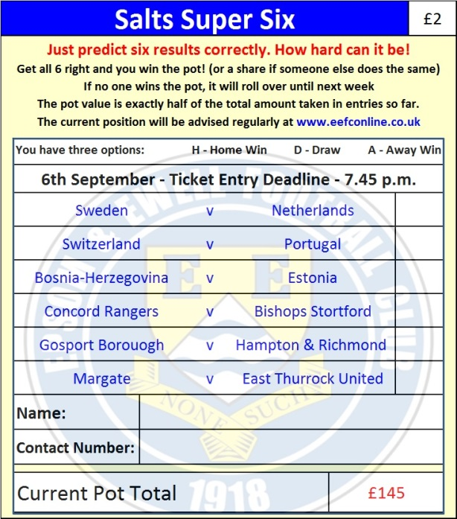

Good luck!

Combined Counties League Cup – First Round
Tuesday, 6th September 2016 - Kick-off 7.45 p.m.
Epsom and Ewell  (Royal Blue & White hoops) | V |  | Abbey Rangers  (Black and White/Black/Black)
Squad | NUMBERS
Michael Eacott |  |  | Liam Stone
James Taylor |  |  | George Davies
Matt Tanton |  |  | James Shannon
© Dan Dean |  |  | Dale Webb
Craig Hastings |  |  | Tom Bentley
Savvas ‘Agi’ Panayiotou |  |  | Joe Macklin
Rob Hendry |  |  | Marcus Aristide
Matt Farrell |  |  | John Sherratt
Daryl Cooper-Smith |  |  | Tom Arnold
Sam Robinson |  |  | Nick Ford
Reisse Griffin |  |  | Ben Kersley
Matt Ferdinando |  |  | Sam Workman
Adam Heagney |  |  | Jason Robertson
Alex McKay |  |  | Luke Robertson
Jordan Gallagher |  |  | Dariush Noonan
Rhys North |  |  | Elliott Firth
Alistair Turpie |  |  | Michael Carey
Tom Neale |  |  | Danny Hartlebury
Charlie Clark-Gleave |  |  | Paul Hodges
Manu Sale |  |  | Alex Jackson
Glyn Mandeville | MANAGER |  | Mike Woolgar
Matt Smith | ASSISTANT
Steve Eacott / Alex McKay / Jimmy Hendry | COACHES / PHYSIO
REFEREE: S.Orchard
ASSISTANTS: D.Payne, R. van Neikerk
Today’s Match and Match Ball are sponsored
by long serving supporter Paul Merritt

OUR NEXT VISITORS TO HIGH ROAD
Camberley Town
Combined Counties League – Premier Division
Saturday 10th September 2016 – 3.00 p.m.

